Cameron Sauvageau Engineering Notebook

Hardware Team

9/26/24:

Today I did about 2.5 hours of research on hardware and movement to get more familiar with the robot and what parts we should look into ordering. I did a lot of research into what parts work best together and how they would affect the overall performance of the robot.

9/27/24:

Today I did a little bit of research on materials. Focused on the robotic arm and what the best material would be to use if we made it ourselves. Didn't want it to be too heavy but durable so 3D printing would most likely be the best idea or to just order the arm already built.

10/03/24:

Today we had a meeting about the scope of our project. The Navy wants to get involved and want us to be able to track UAV instead of human life forms. This doesn't change too much on the hardware side except we would have to work with satellites now. I have never really worked with satellites so will definitely have to do some research. We also would not have a need for the robotic arm so no reason to order that right now or worry about it. Since we haven't been able to order parts, so we are starting to get behind.

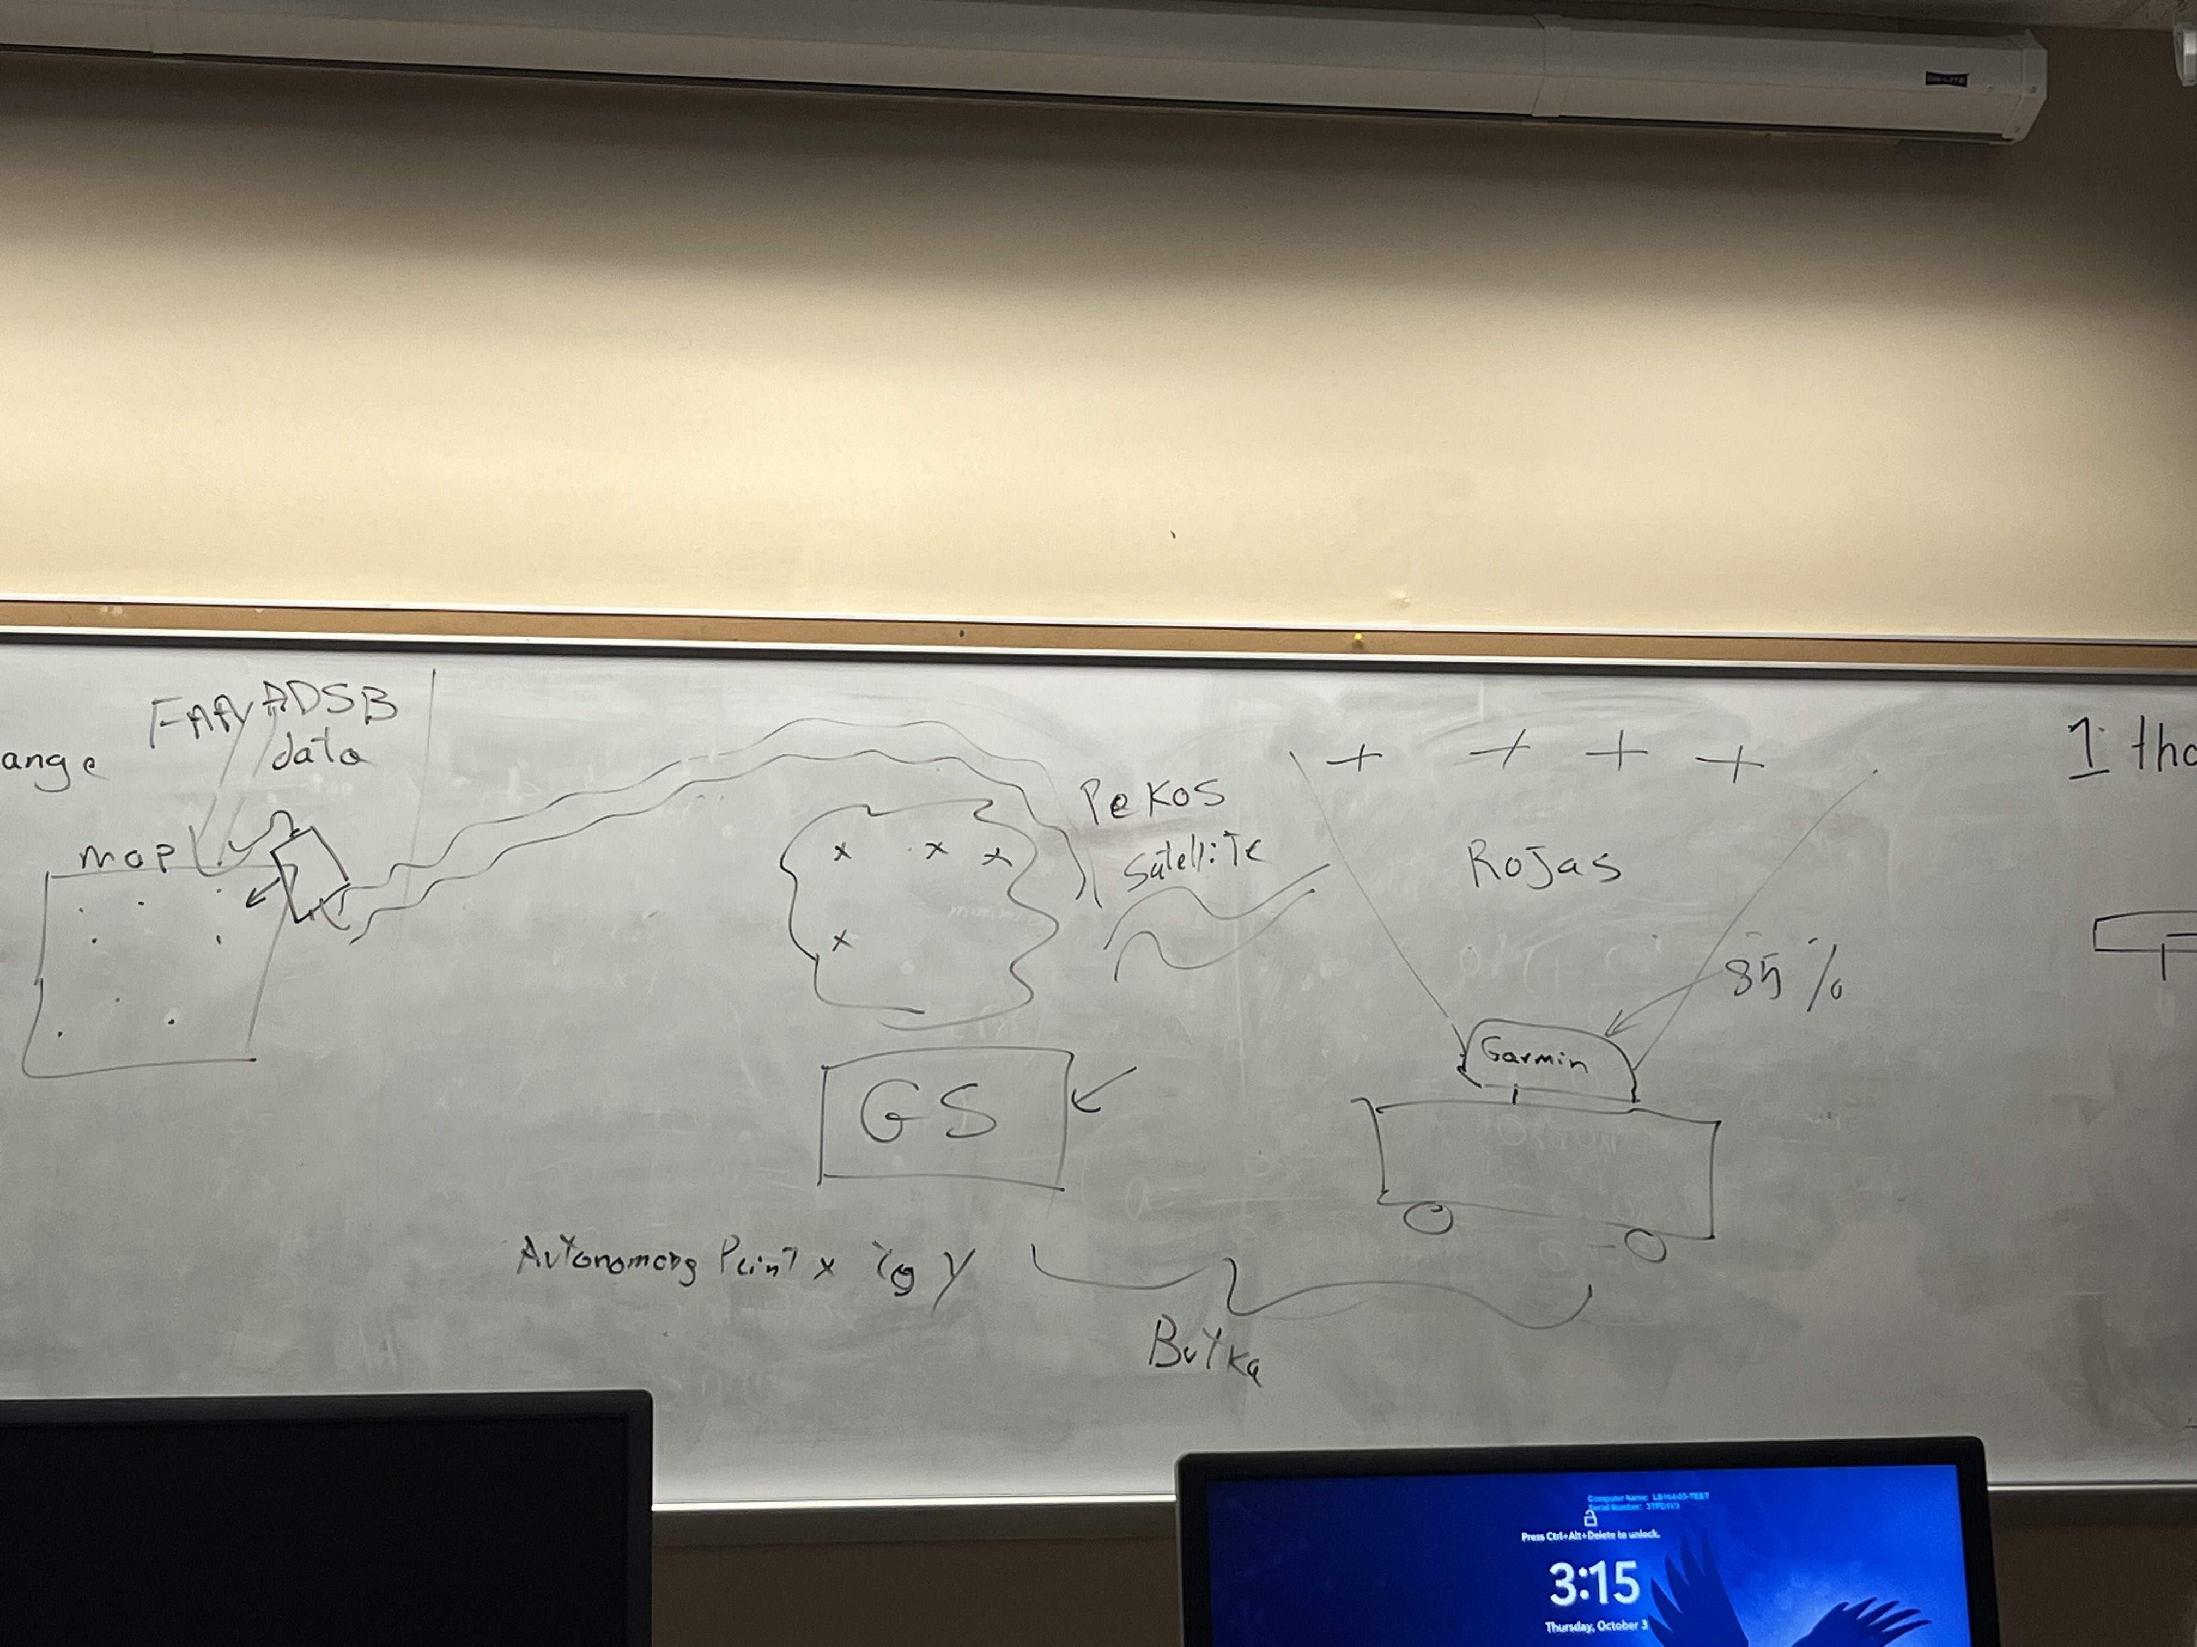

10/09/24:

Did some research into satellites and radars that we can use for UAVS/planes. It is definitely going to be a little bit more complicated if we go along with this new scope based on the research, but it can definitely be done.

I also worked on requirements for the robot. Very generic ones but allowed us to get a rough idea on what the main focuses should be for us as a team.

I also did some work on the presentation and finished up the hardware section before the hurricane hit.

10/18/24:

Solidified the robotic arm we are going to order and sent it to the group via discord. The arm is very mobile, and the end can easily be taken off to add the temp sensor to read the body's temperature. Also, the weight of the arm will counteract the weight of the battery since we plan to have the arm in the front of the robot and the battery in the back.

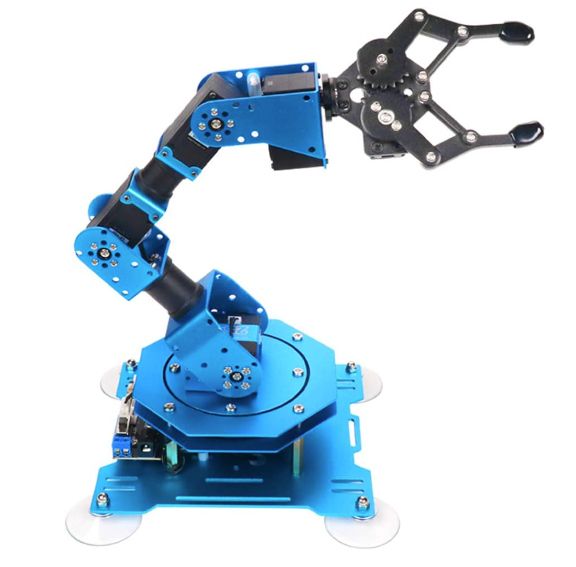

10/21/24:

Today I worked on more requirements due to having to delete some from the research that I did on satellites and UAVs. The requirements will be a work in progress as we do more work on the robot but so far, they have created a solid base to build from.

10/24/24 (Sprint 3):

Today I worked on more requirements and just getting them polished out into not functional and functional requirements.

10/29/24 (Sprint 4):

Start of Sprint 4, Confirmed the measurements in the lab to make sure that we are ready to start 3D printing the Battery Chassis and also the main compartment to hold all the connections and make sure they are organized.

10/30/24 (Sprint 4):

Today I worked on the SDD, just getting started on it and making sure I knew what we needed to get done as the hardware team.

11/3/24 (Sprint 4):

I started 3D printing today and drawing out designs for how I would want to organize the Robot to make sure everything fit in their 3D printed compartments. The robot has a good bit of space but if everything is just thrown on there and not organized, we will definitely run out of space and not have secure connections.

11/4/24 (Sprint 4):

I had layering issues with the 3D printed case for the battery so had to recalibrate the printer and start over. I will also need more material for the other prints, so I made sure to order more online in the future.

11/6/24 (Sprint 4):

Updated some of the requirements in the SRS since we will have the second version due pretty soon and we needed to make edits based on the feedback on our first version.

11/10/24 (Sprint 4):

Spent more time 3D printing some other cases for other components of the robot to make sure that they fit. For now, they fit but I have a feeling that not everything will fit but I can always 3D print some mini shelves to glue on the side of the robot to secure some of the components.

11/12/24 (Sprint 5):

Continued work on the SDD since the due date is coming up. Specifically worked on some of the hardware architecture section.

11/15/24 (Sprint 5):

Got the measurements for the control box so that I can start 3D printing. Created the file for the print just must wait for my roommate to be done using it.

11/16/24 (Sprint 5):

Started printing the control box and continued working on the SDD.

11/19/24 (Sprint 5):

Did some work in the lab with the group and then went up and referenced the posters in order to get ideas for ours.

11/21/24 (Sprint 5):

Added some finishing touches to the SDD and then fixed layering issues with the 3D printer.

11/24/24 (Sprint 5):

Setup the control box with all its components and realized that there is not enough space and would have to redesign the layout for the components on the robot.

11/26/24 (Sprint 6):

Start of sprint 6 and while in the lab looked over the SRS one last time to make any needed adjustments to the requirements and moved some around that were in the wrong sections.

12/1/24 (Sprint 6):

Gap between last time I did work due to Thanksgiving break and visiting family. Printed some shelves to see if they would work well on the robot to place components on such as the raspberry Pi. I realized they were too thin and needed to reprint them but a little thicker.

12/3/24 (Sprint 6):

Recorded my section of the 10-minute Presentation. I thought it went very well and tried to explain my part in a way that someone who knew nothing about our project could understand.

12/5/24 (Sprint 6):

We had our poster presentation today and thought it went very smoothly. Got to break down our project to a couple of other students and their questions actually helped when it came to some issues we may encounter.